Bug Report: BUG_001
Title: Missing Quantity Adjustment (+/-) Icons on Cart Page
Reporter: Mehak Dayalal
Date: April 2, 2026
Status: New / Open

1. Bug Information
- Severity: Medium (The user can't perform a core action—changing quantity—without deleting and re-adding).
- Priority: P2 (Needs to be fixed before the next release).
- Environment: Chrome v120 / Windows 10.
- Feature: Shopping Cart.

2. Description
The Shopping Cart page lacks the UI elements (buttons or icons) required to increase or decrease the quantity of an item once it has been added. The user is forced to go back to the inventory page to add more items.

3. Steps to Reproduce
- Navigate to SauceDemo.com.
- Login with standard_user.
- Add "Sauce Labs Backpack" to the cart.
- Click the Shopping Cart icon to view the cart page.
- Attempt to increase the quantity of the backpack from 1 to 2.

4. Actual Result
There are no "+" or "-" icons or an editable quantity field present on the Cart page.

5. Expected Result
The Cart page should display a "+" icon to increase the quantity and a "-" icon to decrease it, or an editable numeric input field.

6. Evidence
- Screenshot:
- 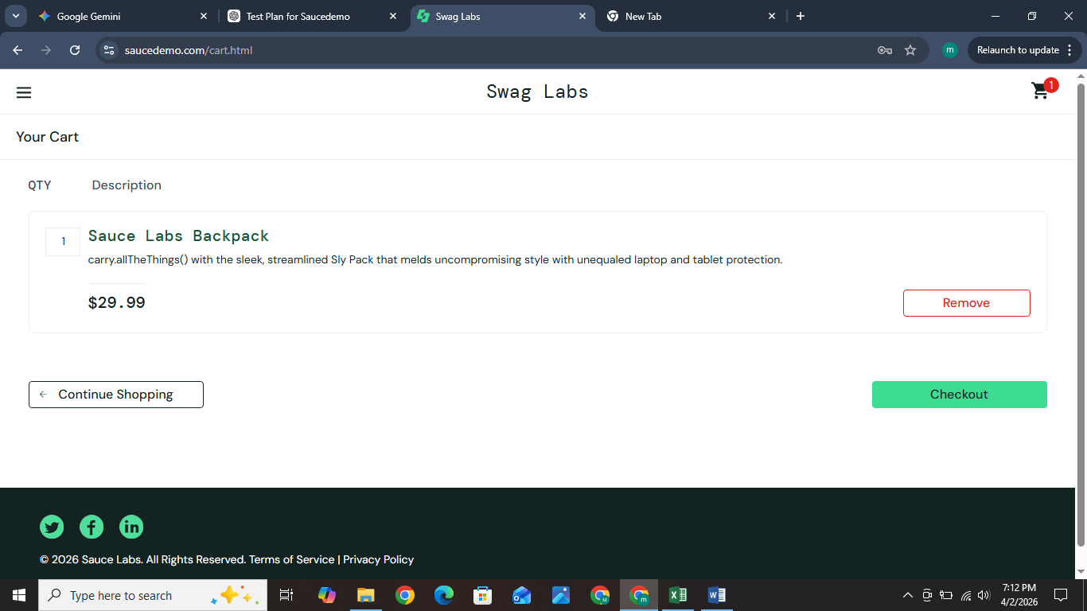

Bug Report: BUG_002
Title: System allows checkout process to proceed with an empty cart ($0.00 Total)
Reporter: Mehak Dayalal
Date: April 2, 2026
Status: New / Open

1. Bug Information
- Severity: High (This is a major logic flaw that affects the order fulfillment process).
- Priority: P1 (Should be fixed immediately to prevent invalid orders).
- Environment: Chrome v120 / Windows 10.
- Feature: Checkout Flow / Validation.

2. Description
The application fails to validate the contents of the shopping cart before allowing access to the checkout pages. A user can navigate to the cart, remove all items, and still click the "Checkout" button. The system then allows the user to enter shipping information and "Finish" the order with a total price of $0.00.

3. Steps to Reproduce
- Open SauceDemo.com and login.
- Add any item (e.g., "Sauce Labs Backpack") to the cart.
- Click the Shopping Cart icon.
- On the Cart page, click the "Remove" button for the item. (The cart is now empty).
- Click the "Checkout" button.
- Enter valid information (First Name, Last Name, Zip) and click "Continue".
- Observe the "Checkout: Overview" page showing Total: $0.00.
- Click "Finish".

4. Actual Result
The system successfully processes the order and displays the "Thank you for your order!" confirmation page, despite the cart being empty and the total being $0.00.

5. Expected Result
The "Checkout" button should be disabled (unclickable) if the cart is empty. Alternatively, an error message should appear stating, "Your cart is empty. Please add items to proceed."

6. Evidence
- Screenshot 1: Showing the Cart page with no items but the Checkout button active.

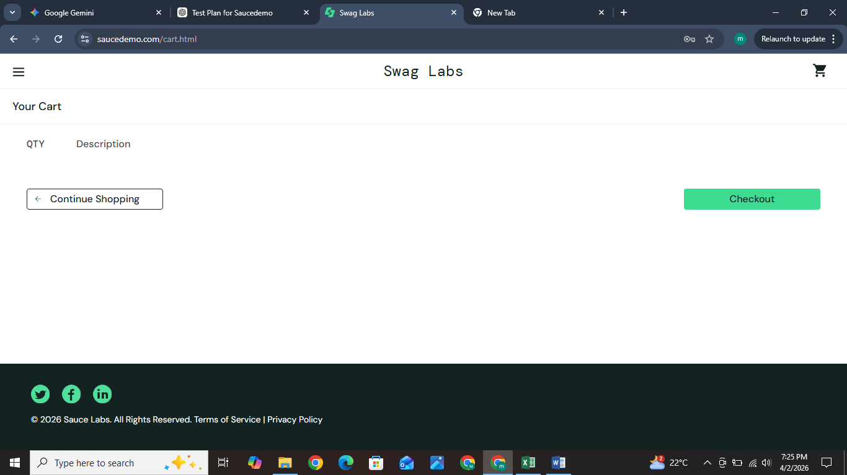

- Screenshot 2: Showing the Final Overview page with Total: $0.00.

